**Module 12 Installation, Storage, and**

**Compute with Windows Server**

Windows Server 2016 Installation Requirements:

To install Windows Server 2016 correctly, your computer must meet the following minimum hardware requirements:

CPU: 1.4 GHz 64-bit processor compatible with x64 instruction set.

RAM: 512 MB for Server Core, 2 GB for Server with Desktop Experience (ECC type recommended).

Storage: At least 32 GB of disk space for the system partition.

Network: An Ethernet adapter capable of achieving at least 1 gigabit per second throughput.

Windows Server 2016 can be installed as a virtual machine, but it might initially fail with only 512 MB of RAM1.

Windows Server 2016 Editions:

Windows Server 2016 comes in several editions:

Standard: Suitable for general-purpose server roles.

Datacenter: Ideal for highly virtualized environments with unlimited virtual machines.

Essentials: Designed for small businesses with up to 25 users and 50 devices.

Hyper-V: A free version for running the Hyper-V role only.

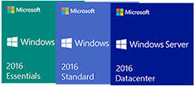

Adding and Removing Server Roles:

**Step 1.** On your server dashboard click "manage" and after click "remove roles and features".

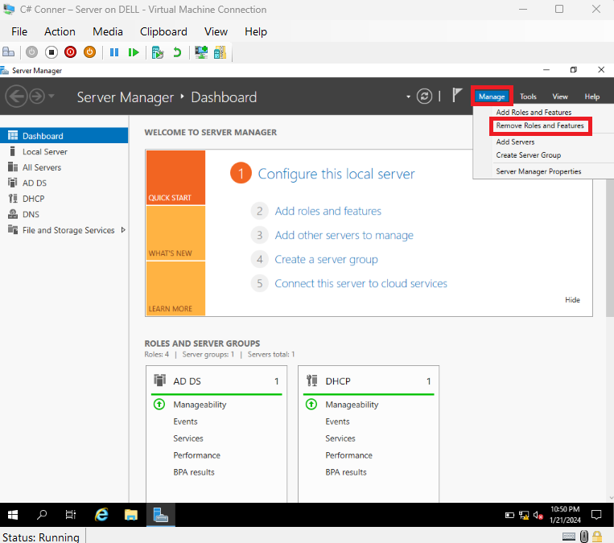

**Step 2.**Click "next".

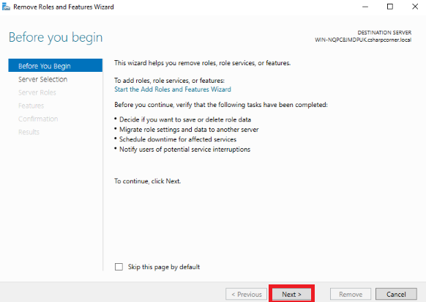

**Step 3.**Again click "next".

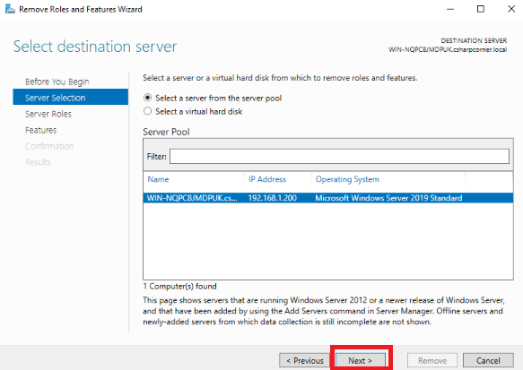

**Step 4.**Here you can remove the roles by clicking roles now I’m going to remove "active directory domain services.

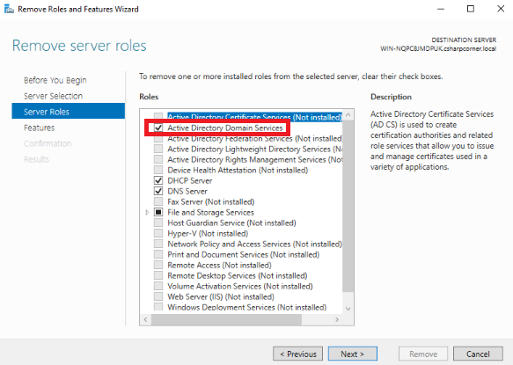

**Step 5.**Once untick the roles you will receive a wizard click "remove features".

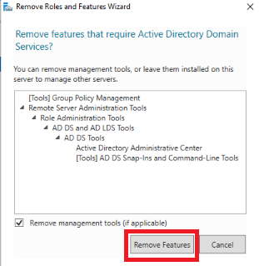

**Step 6.**Click "demote this domain controller".

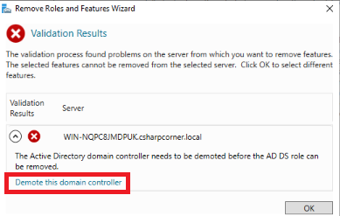

**Step 7.**Click "force this removal of this domain controller" and after click "next".

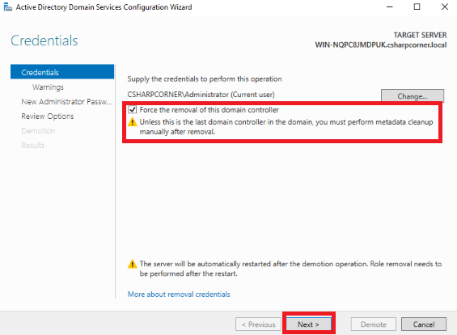

**Step 8.** Click "Proceed with removal" after clicking "Next".

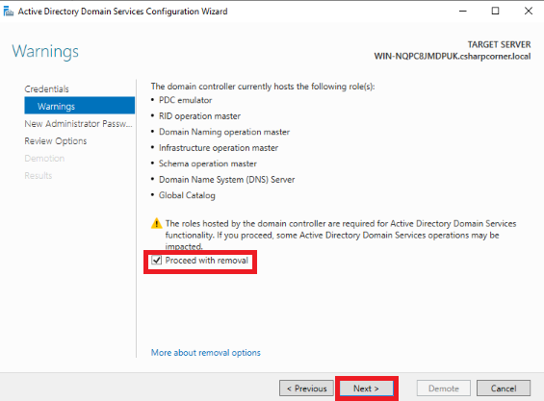

**Step 9.**Give your server’s password and click "next".

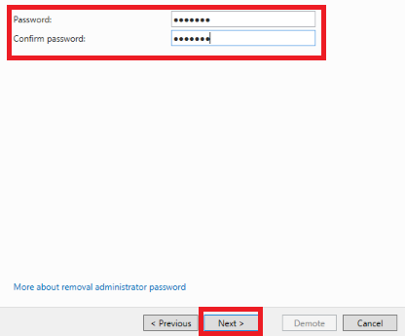

**Step 10.**Click "demote".

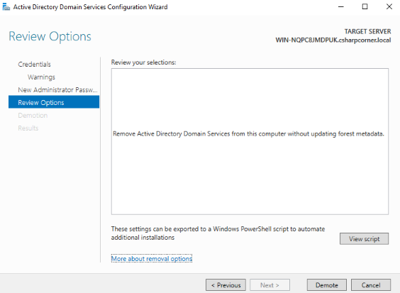

**Step 11.**After now you can see the message, that your server going to restart.

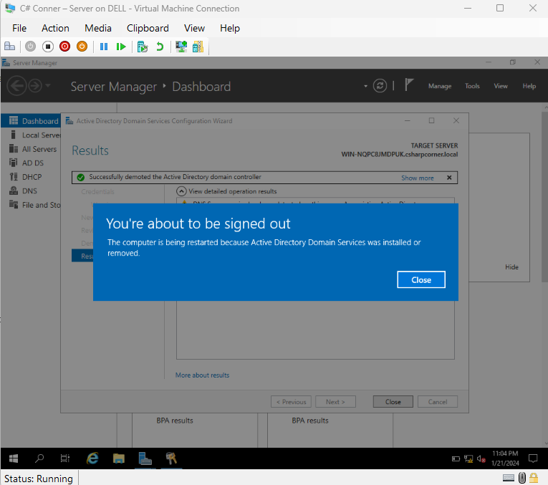

Workgroup:

In networking, a workgroup is a collection of computers on a local area network (LAN) that share common resources and responsibilities.

Workgroups allow peer-to-peer communication and collaboration among connected devices.

Windows workgroups are commonly found in homes, schools, and small businesses.

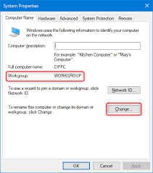

Domain:

A domain refers to any group of users, workstations, devices, printers, computers, and database servers that share different types of data via network resources.

Domains are used for centralized management of user functions, authentication, access control, and resource privileges.

Windows domains support client-server local networks, while workgroups are peer-to-peer networks.

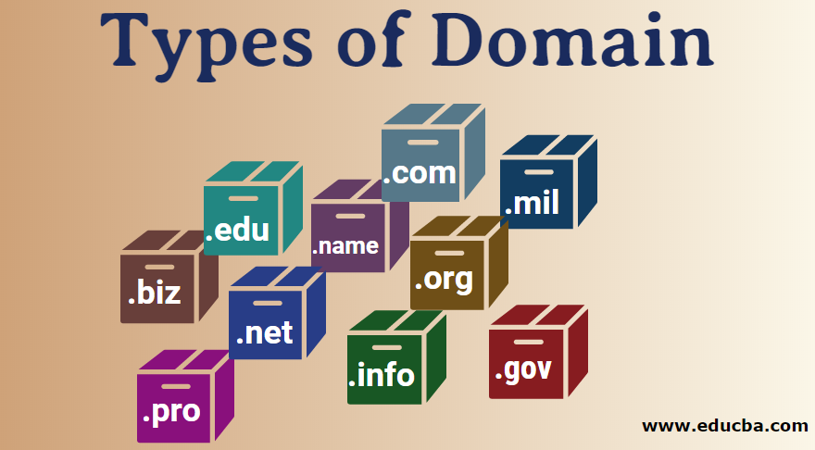

**What is powershell**

PowerShell is a versatile task automation solution that combines a command-line shell, a scripting language, and a configuration management framework. Here are the key points about PowerShell:

**Command-Line Shell:**

PowerShell is a modern command shell that goes beyond text-based input/output.

It accepts and returns .NET objects, allowing seamless integration with other tools and systems.

Features include robust command history, tab completion, aliases, and pipeline support.

Scripting Language:

PowerShell is commonly used for automating system management tasks.

Built on the .NET Common Language Runtime (CLR).

Supports functions, classes, scripts, modules, and various data formats (CSV, JSON, XML).

Automation Platform:

PowerShell’s extensibility enables an ecosystem of modules for managing various technologies (e.g., Azure, Windows, SQL).

Desired State Configuration (DSC) allows managing infrastructure as code.

**Upgrade vs. Migration:**

Upgrade: Moving from an older version to a newer version while staying on the same hardware.

Migration: Transferring data from an old system to a new system (could involve different hardware or virtual machines).

**Migration Limitations:**

When migrating roles and features in Windows Server, there are some limitations to be aware of:

Windows Server Migration Tools: While powerful, it has limitations in the scope of roles, features, settings, and other data that can be migrated from a legacy server to a destination.

Storage Migration Service: Doesn’t transfer files exclusively locked by applications, but it automatically retries and allows rerunning transfers1.

**Advantages of Server Core:**

Smaller Footprint: Server Core has a smaller disk footprint, reducing resource usage.

Reduced Attack Surface: Fewer services mean a smaller code base and less exposure to security risks.

Faster Reboots: Minimal services lead to faster restarts after updates.

Ideal for Hyper-V Hosts and Containers.

**Nano Server:**

Purpose: Nano Server is a lightweight, 64-bit server OS deployed via containers.

Benefits:

Less Frequent Updates and Reboots: Pared-down services reduce patching needs.

Smaller Server Images: Ideal for cloud-based applications and VMs.

Secure and Manageable: Designed for remote management through PowerShell or GUI tools like RSAT or Windows Admin Center.

**Comparison:**

GUI: Full graphical interface with more features.

Core: Minimal installation, suitable for specific roles.

Nano: Ultra-lightweight, ideal for specific workloads.

**Install Server 2016 GUI:**

Step 1: Open PowerShell as an administrator.

Step 2: Run the following command:

Install-WindowsFeature Server-Gui-Shell -Restart

This command installs the full graphical user interface (GUI) on a Windows Server 2016 system that already has the “MinShell” (minimal GUI) installed. The -Restart flag ensures that the server reboots after installation.

**Install Server 2016 Server Core:**

Step 1: During installation, choose the “Windows Server 2016” option (not “Windows Server 2016 (with local admin tools)”) to install Server Core.

Step 2: Server Core is a minimal installation option without a graphical user interface. It provides a lightweight and secure environment for specific server roles.

**Assign Dual IP Address on LAN Card:**

Step 1: Open Network Connections (you can press WinKey+R and type ncpa.cpl).

Step 2: Right-click on the network adapter and select Properties.

Step 3: Select TCP/IP v4 (or v6) and click Properties.

Step 4: Click Advanced and then Add in the IP Addresses section.

Step 5: Specify the additional IP address and subnet mask.

Step 6: Save the changes. Now your server will have dual IP addresses on the LAN card.

**Upgrade Server 2012 to Server 2016:**

Step 1: Ensure you have a valid product key for Windows Server 2016.

Step 2: Download the Windows Server 2016 ISO file from Microsoft.

Step 3: Mount the ISO file and run the setup.exe.

Step 4: Choose the “Upgrade” option during installation. This will upgrade your existing Server 2012 installation to Server 2016.

**Change Computer Name:**

On Windows 10 or Windows 11:

Go to Start > Settings > System > About.

Select “Rename this PC.”

Enter the new name and follow the prompts.

On Windows Server:

Open PowerShell as an administrator.

Run:

Rename-Computer -NewName NewComputerName -Restart

Replace NewComputerName with the desired name.

**Install Nano Server:**

Note: Nano Server is deprecated in Windows Server 2019 and later versions. However, if you still want to explore it:

You can create a Nano Server image using PowerShell and the NanoServerImageGenerator module.

Follow the official documentation for detailed instructions.

**Manage and Configure a Nano Server:**

Step 1: Nano Server is managed remotely using PowerShell or other management tools (like Windows Admin Center).

Step 2: Use PowerShell remoting to connect to the Nano Server and configure roles, features, and settings.

**Configure Network in Nano Server:**

Step 1: Use PowerShell remoting to connect to the Nano Server.

Step 2: Configure network settings using New-NetIPAddress and Set-DnsClientServerAddress cmdlets.

**Join Nano Server in Domain:**

Step 1: Use PowerShell remoting to connect to the Nano Server.

Step 2: Run:

Add-Computer -DomainName YourDomain -Credential (Get-Credential)

Replace YourDomain with your actual domain name.

You’ll be prompted to enter domain credentials.

**Storage solution**

**GPT vs. MBR:**

GPT (GUID Partition Table):

GPT is a newer partitioning scheme used for organizing data on storage devices.

Advantages:

Supports larger disk sizes (up to 64TB).

More robust and resilient against corruption.

Allows unlimited primary partitions.

Used primarily with UEFI-based systems.

MBR (Master Boot Record):

Older partitioning scheme.

Advantages:

Compatible with legacy systems.

Simpler structure.

Supports up to 2TB disk size.

Limited to four primary partitions (or three primary and one extended partition).

**VHD vs. VHDX:**

VHD (Virtual Hard Disk):

Older format for virtual hard disks.

Maximum drive size: 2TB.

Widely supported by various virtualization software.

VHDX (Virtual Hard Disk Extended):

Newer format with advantages:

Maximum drive size: 64TB.

Better performance with modern hardware.

Protection against data corruption.

Mainly used in Microsoft Hyper-V environments.

**SMB and NFS:**

SMB (Server Message Block):

Windows-based file sharing protocol.

Used for sharing files, printers, and other resources.

Integrates deeply with Windows products.

NFS (Network File System):

Unix-based file sharing protocol.

Created by Sun Microsystems.

Popular among Linux users.

Allows clients to access files on remote servers.

**Sharing Permissions:**

Share Permissions:

Control access at the share level.

Apply to all files and folders within the share.

Simpler to manage but less granularity.

Three main levels: Full Control, Change, Read.

**NTFS Permissions:**

NTFS Permissions:

Control access to files and folders on NTFS volumes.

More granularity than share permissions.

Inherited from parent folders.

Levels include Full Control, Modify, Read & Execute, etc.

**Resource Ownership:**

Resource ownership refers to the user or group that has control over a particular resource (file, folder, etc.).

Ownership determines who can modify permissions and access the resource.

**Storage Pool:**

A collection of physical disks combined into a single logical unit.

Used for redundancy, performance, or capacity expansion.

Managed by Windows Storage Spaces or similar technologies.

**Basic Disk vs. Dynamic Disk:**

Basic Disk:

Traditional disk type.

Supports primary and extended partitions.

No fault tolerance features.

Dynamic Disk:

Supports dynamic volumes (spanned, striped, mirrored, RAID-5).

Offers fault tolerance and flexibility.

Simple Volume vs. Spanned Volume:

**Simple Volume:**

Uses space from a single disk.

No fault tolerance.

**Spanned Volume:**

Combines space from multiple disks.

No fault tolerance but increased capacity.

**RAID Levels:**

RAID 0 (Striping): Data striped across multiple disks for performance. No redundancy.

RAID 1 (Mirroring): Data duplicated on two disks for fault tolerance.

RAID 5: Distributed parity across multiple disks. Fault tolerance with better capacity utilization.

RAID 6: Similar to RAID 5 but with dual parity for additional fault tolerance.

RAID 10 (1+0): Combines mirroring and striping for both performance and redundancy.

**DAS, NAS, and SAN:**

DAS (Direct-Attached Storage): Storage directly connected to a server (e.g., external hard drives).

NAS (Network-Attached Storage): File-level storage accessed over a network.

SAN (Storage Area Network): Block-level storage accessed over a dedicated network.

**iSCSI Initiator and Target:**

iSCSI Initiator: Software or hardware component that initiates iSCSI connections to access remote storage.

iSCSI Target: Remote storage system that responds to iSCSI requests.

**Data Duplication:**

Technique to create redundant copies of data for fault tolerance.

Ensures data availability even if one copy fails.

**Share a Folder and Give Read/Write Permission to the First User:**

To share a folder in Windows and give read/write permissions, follow these steps:

* Locate the Folder: Use File Explorer to find the folder you want to share.
* Right-Click and Select Properties: Right-click on the folder and choose “Properties.”
* Go to the Sharing Tab: Click on the “Sharing” tab.
* Click “Advanced Sharing”: Click the “Advanced Sharing” button.
* Check “Share this folder”: Enable the checkbox to share the folder.
* Set Permissions: By default, users in the “Everyone” group will have read-only access. To grant read/write permissions to specific users, click the “Permissions” button and adjust the settings1.

**Share the “Data” Folder and Give Read Permission to Another User:**

Follow the same steps as above, but when setting permissions, grant “Read” access to the desired user instead of “Full Control” or “Change” permissions2.

**Share the “Data” Folder, Create a File, Remove Inheritance, and Set Different NTFS Permissions:**

* Share the Folder: Follow the steps from the first request to share the “Data” folder.
* Create a File: Create a file within the shared folder.
* Remove Inheritance: Right-click on the folder, go to “Properties,” and under the “Security” tab, click “Advanced.” Uncheck the option to inherit permissions from the parent folder.
* Set Different NTFS Permissions: Adjust the permissions for individual users or groups by clicking “Edit” in the Security tab. You can grant specific permissions (e.g., read, write, modify) to different users3.

**Configure RAID 1 and Check Redundancy:**

RAID 1 (Mirroring) duplicates data across two drives for redundancy. To set up RAID 1:

Install Two Identical Drives: Ensure you have two identical drives.

Access BIOS/UEFI: During boot, enter BIOS/UEFI settings.

Configure RAID: Look for RAID settings (usually under SATA or Storage options) and set up RAID 1.

Initialize RAID: Initialize the RAID array.

Check Redundancy: Verify that data is mirrored between the drives.

**Configure RAID 5 and Check Redundancy:**

RAID 5 stripes data across multiple drives with parity. To set up RAID 5:

Install at Least Three Drives: You need a minimum of three drives.

Access BIOS/UEFI: As before, enter BIOS/UEFI settings.

Configure RAID: Set up RAID 5.

Initialize RAID: Initialize the RAID array.

Check Redundancy: Verify that data is distributed with parity.

**Configure iSCSI Target and Initiator for Remote Storage:**

iSCSI allows remote storage access over a network:

iSCSI Target Setup:

Install an iSCSI target software (e.g., Microsoft iSCSI Target).

Create an iSCSI target (virtual disk) and configure access permissions.

iSCSI Initiator Setup:

On the client machine, enable the iSCSI Initiator service.

Discover the iSCSI target (provide its IP or hostname).

Connect to the target and allocate remote storage.

**Configure Data Deduplication:**

Data deduplication reduces storage space by eliminating duplicate data:

Enable Data Deduplication:

Open PowerShell or Command Prompt as an administrator.

Run: Enable-DedupVolume -Volume <drive_letter>.

Set Deduplication Schedule:

Configure when deduplication runs (e.g., during off-peak hours).

Monitor and Verify: Monitor deduplication savings and verify data integrity.

**What is Virtualization?**

Definition: Virtualization is a technique that allows you to create a virtual (software-based) version of something, such as computer hardware or an operating system. It separates a service from the underlying physical delivery of that service.

Purpose: To increase resource utilization, flexibility, and cost-effectiveness.

Examples: Creating virtual machines (VMs) that run multiple operating systems on the same physical hardware.

Benefits:

Efficiently share physical resources.

Run legacy software.

Experiment with different OSes.

Improve disaster recovery.

Drawbacks:

Initial investment.

Need for skilled staff.

Types:

Application virtualization.

Network virtualization.

Desktop virtualization.

Storage virtualization.

Server virtualization.

Data virtualization1.

**Types of Virtualization and Comparison:**

There are several types of virtualization:

Server Virtualization: Run multiple VMs on a single physical server. Examples include VMware vSphere and Microsoft Hyper-V.

Storage Virtualization: Abstract storage resources from physical devices, allowing centralized management.

Network Virtualization: Create virtual networks that operate independently of the physical network infrastructure.

Desktop Virtualization: Deliver desktop environments to users remotely.

Application Virtualization: Isolate applications from the underlying OS, improving compatibility.

Comparison:

Type 1 (Bare Metal) Hypervisor: Runs directly on the physical hardware (e.g., VMware ESXi, Hyper-V). More efficient but requires dedicated hardware.

Type 2 (Hosted) Hypervisor: Runs on top of an existing OS (e.g., VMware Workstation, VirtualBox). Easier to set up but less efficient2.

**Hyper-V:**

Definition: Microsoft’s hardware virtualization product.

Purpose: Create and manage VMs on Windows systems.

Features:

Hardware Virtualization: Each VM runs on virtual hardware.

Hyper-V Manager: GUI tool for managing VMs and hosts.

Operating System Support: Various Windows and Linux OSes.

Differences from Hyper-V on Windows Server: No live migration, Hyper-V Replica, or SR-IOV networking on Windows3.

**Remote Management of Hyper-V:**

Hyper-V Manager: An administrative tool for managing Hyper-V hosts and VMs both locally and remotely.

Steps:

Enable remote management on the Hyper-V host.

Configure WinRM service and allow CredSSP authentication.

Install Hyper-V Manager on the client computer.

Add an entry to the client’s hosts file to make the host accessible by name4.

**Hyper-V Manager**:

Definition: An administrative tool for creating, managing, and deleting VMs. It provides a GUI interface for centralized management of Hyper-V environments.

Use Cases: Configure Hyper-V hosts and VMs both locally and remotely.

Compatibility: Works with Windows Server Core or Hyper-V Server without a GUI5.

**Virtual Machine (VM) and Nested Virtualization:**

VM: A software-based representation of a complete computer system, including an OS and applications. VMs run on virtual hardware provided by the hypervisor.

Nested Virtualization: Running a VM inside another VM. Useful for testing and development scenarios.

**Dynamic Memory:**

Hyper-V Feature: Dynamically adjusts VM memory allocation based on demand.

Benefits: Efficiently utilizes memory resources by allocating more when needed and reclaiming unused memory.

**NUMA (Non-Uniform Memory Access):**

Definition: A hardware architecture where processors have different access times to memory.

Hyper-V and NUMA: Hyper-V optimizes VM placement to minimize memory latency in NUMA systems.

**Virtual Machine Functions:**

Creation and Configuration: Create VMs, allocate resources, and configure settings.

Start/Stop Operations: Power on/off VMs.

Snapshot/Checkpoint: Capture VM state at a point in time.

Networking: Configure virtual NICs, switches, and network settings.

Storage: Attach virtual hard drives (VHDs/VHDX) and manage storage.

**Hyper-V Functions:**

Live Migration: Move running VMs between hosts without downtime.

Replication: Replicate VMs to another host for disaster recovery.

Virtual Switches: Create and manage virtual networks.